KPI’S

Total Revenue

1. SELECT SUM(total_price) Total_Revenue from pizza_sales



Average Order value

1. SELECT SUM(total_price)/ COUNT(DISTINCT order_id) Avg_Order_Value from pizza_sales



Total Pizza sold

1. SELECT SUM(quantity) Total_Pizza_Sold FROM pizza_sales



Pizza Sold by Category

1. SELECT pizza_category,SUM(quantity) Total_Quantithy FROM pizza_sales GROUP BY pizza_category

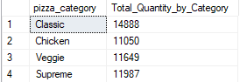

Pizza Sold by Size

1. SELECT pizza_size, SUM(quantity) Total_Quanity_by_Size FROM pizza_sales GROUP BY pizza_size ORDER BY Total_Quanity_by_Size DESC

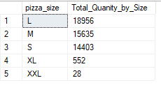

Total Order placed

1. SELECT COUNT(DISTINCT order_id) Total_Orders FROM pizza_sales



Avg Pizza’s per order

1. SELECT CAST(CAST(SUM(quantity) AS decimal(10,2))/CAST(COUNT(DISTINCT order_id) AS decimal(10,2)) AS decimal(10,2)) Avg_Pizza_Per_Order FROM pizza_sales



TREND’S

Order Count as per week days

1. SELECT DATENAME(DW, order_date) DAY_, COUNT(DISTINCT order_id) Orders_Count FROM pizza_sales GROUP BY DATENAME(DW, order_date)

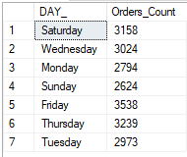

Monthly Order count

1. SELECT DATENAME(MONTH, order_date) Month, COUNT(DISTINCT order_id) Orders_Count FROM pizza_sales GROUP BY DATENAME(MONTH, order_date)

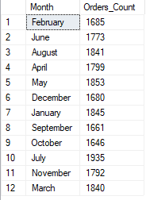

1. SELECT pizza_category, SUM(total_price) Total_Sales, CAST(SUM(total_price) * 100 / (SELECT SUM(total_price) FROM pizza_sales) AS decimal(10,2)) PCT FROM pizza_sales

GROUP BY pizza_category

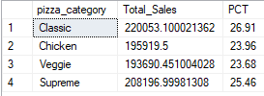

Category wise sales and percentage sales

1. SELECT pizza_category, SUM(total_price) Total_Sales, CAST(SUM(total_price) * 100 / (SELECT SUM(total_price) FROM pizza_sales WHERE MONTH(order_date) = 1) AS decimal(10,2)) PCT

FROM pizza_sales

WHERE MONTH(order_date) = 1

GROUP BY pizza_category

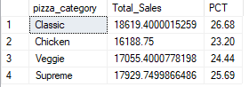

Size wise sales and percentage sales

1. SELECT pizza_size, CAST(SUM(total_price) AS decimal(10,2)) Total_Sales, CAST(SUM(total_price) * 100 / (SELECT SUM(total_price) FROM pizza_sales) AS decimal(10,2)) PCT

FROM pizza_sales

GROUP BY pizza_size

ORDER BY PCT DESC

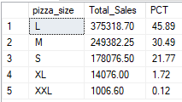

TOP

Top 5 pizza’s by total sales

SELECT TOP 5 pizza_name_id, SUM(total_price) Total_Sales FROM pizza_sales

GROUP BY pizza_name_id

ORDER BY Total_Sales DESC

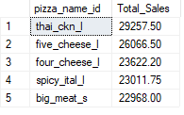

Bottom 5 pizza’s by total sales

SELECT TOP 5 pizza_name_id, SUM(total_price) Total_Sales FROM pizza_sales

GROUP BY pizza_name_id

ORDER BY Total_Sales

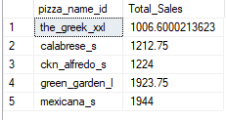

Top 5 pizza’s by quantity

SELECT TOP 5 pizza_name_id, COUNT(quantity) Total_Quantity FROM pizza_sales

GROUP BY pizza_name_id

ORDER BY Total_Quantity DESC

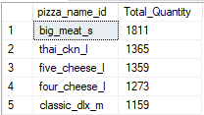

Bottom 5 pizza’s by Quantity\

SELECT TOP 5 pizza_name_id, COUNT(quantity) Total_Quantity FROM pizza_sales

GROUP BY pizza_name_id ORDER BY Total_Quantity

